Infinity Mirror Project Proposal

Description
In essence, an infinity mirror creates an illusion of infinite mirrors when you look into it. In order to work, a light source between two mirrors is needed; a normal one and the other one must be a one-way mirror or also known as a two-way mirror. A one-way mirror allows for the side with more light to be seen no matter from which side it is viewed from. In this case, an LED strip is a toggleable light source to allow for the user to choose which side will be brighter. When the LEDs are off, it appears to be just an ordinary mirror. However, when the LEDs are turned on, the user would see the inside since the brighter perspective would be from that side. The one-way mirror would reflect almost all the light that is emitted from the LEDs onto the normal mirror, and from there, the image reflected would then again be entirely reflected onto the one-way mirror; creating an endless loop where an endless amount of LEDs can be seen until the light can be seen no more.

Infinity Mirror Project Proposal An infinity mirror with various unique features will be made, which will be majorly focused on the visuals of the LEDs and ease of the user interface component. More details can be found in the Feature List Section.

Examples/concepts/inspirations found online:
Instructables: RGB LED Infinity Mirror w/ Potentiometers
IR Remote-Controlled RGB LED
Wireless LED Lamp w/ IR Remote
How to Program IR Remote Control
Youtube: Using IR Remote Controls with the Arduino

Feature List
- Hangs on wall with a thumb tack (eg. like a clock)
  - Power cable doesn’t interfere
  - IR receiver doesn’t interfere either
- Functions as a normal mirror while off
- On and off button
  - Let user change default for startup
- RGB LEDs
- Change colours to remain constant
- Colour transitions
  - “Default”
    - Steadily changes colour w/out any significant transitions
  - Fades in and out
    - Fade in = desired colour
    - Fade out = slowly brightness down until off
  - Chasing / rotates
    - Eg. reloading symbol
  - Pulsates
    - Use delays to make it look like light is sent into oblivion of the abyss
    - Make light spiral into the abyss?
- Change speeds & brightness
  - + & - buttons
  - Concept for ‘ctrl + x’ for changing/adjusting multiple features
    - Creates twice the amount of commands/inputs
- ✨ I N F I N I T E H U E S O F P U R P L E ✨
  - Set range of ✨ purple ✨ hues \(^-^)/
  - IR remote control buttons as well?
- Convenience of remote control
  - Velcro to the back panel
    - Can be put away safely w/out forgetting spot
    - Can be kept out if wanted as intended
- Switch from between power plug and battery
  - If both are present, take from power adapter
- Set range for colour transitions
  - Eg. blue to purple

Equipment Required
All parts can be found in the Google Sheets document, Infinity Mirror Parts List. There are two separate pages; one exclusively for parts from Abra Electronics, while the other includes all the parts necessary for the infinity mirror.

Rough Sketches
***Two or three quick sketches that visually explain some of the main ideas of your project. Hand drawn sketches are encouraged.

The images below explain how a one-way mirror works and an infinity mirror works.
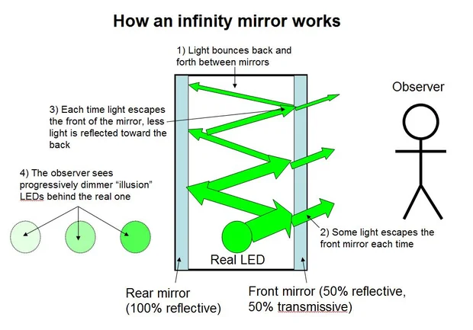
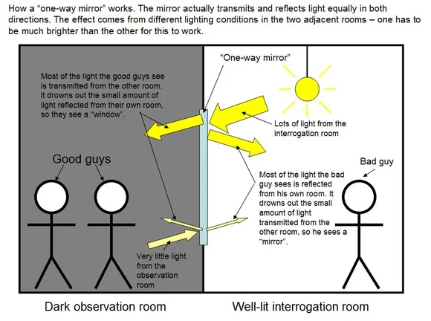

The general layout of how all the parts will look and be placed from the side, front, and back perspective.
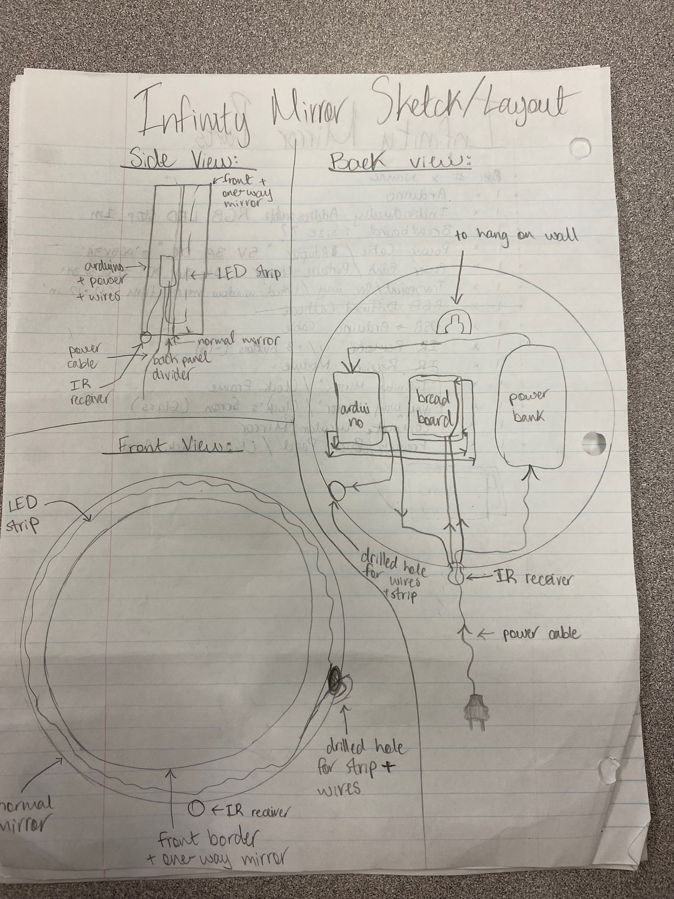

Project Plan
*please make note that countless steps are solely for double or triple checking to ensure accuracy and to decrease all mistakes possible
- Gather all materials needed
- Work on code in the meantime
  - Test on Tinkercad
- Test all wiring + code + remote control
  - All technical components & features
  - Everything should work except for the actual “infinity mirror” part
- Check how well mirror fits into back panel
- Apply transparent mirror film to glass
  - Ensure it is clean (before & after), no bubbles, good reflectiveness, no scratches
- Temporarily? place glass & mirror into frame & back panel respectively
  - Ensure correct reflectiveness and which side is front & back
- Remove mirror
- Clean glass
- Permanently place glass into frame
  - Cautious of fingerprints
  - Oh wait…I shouldn’t
  - If frame is bent, might force glass to crack/shatter
- Test LED Strip
  - Each one works
  - Entire strip can handle; ½ (r/g/b), full (r/g/b), 2 (½ (r/g/b)), 2(full(r/g/b)), all white
  - Each of feature options
  - Works with both battery & power cable
- Temporarily place mirror
- Temporarily place LED strip along inner rim of back panel
  - Ensure centering from glass to mirror
  - Measure how much to cut off if necessary
- Measure and draw outline on back panel
- Measure and draw outline of mirror
- Remove mirror
- Figure out where to drill holes for wires
  - Dw about if it’s too small, can always make it bigger, but not vice versa
  - Ensure where LED strip aligns needs to be cut
- Draw drill holes on back panel
- Temporarily place LED strip
  - Ensure where LED strip aligns needs to be cut
- Ensure drill holes align with LED strip’s wires and caution of how to install LED strip
- Remove LED strip
- Drill holes
- Cut LED Strip (maybe 1 LED bigger than needed)
- Solder ending wires to end of newly cut LED strip
  - Consider if end of wire fits through the drilled hole
- Ensure LED strip + wire fit how needed
- Sand holes down with sandpaper
  - To ensure wires don’t get damaged during contact with hole
- Temporarily place LED strip and ensure LED strip’s wires and caution of how to install LED strip
- Test all features of LED strip
- Temporarily test all features with glass, LED strip, mirror
- Permanently place mirror & LED strip
  - Use double sided tape if necessary
- Test all features with glass, LED strip, mirror
- Finalise all placements
  - Use velcro for arduino
  - Use masking tape (/zip ties?) for grouping wires

TO BE COMPLETED BY YOUR TEACHER

Approved: Yes / No

Required Changes To Proposal:

Other Suggestions:

